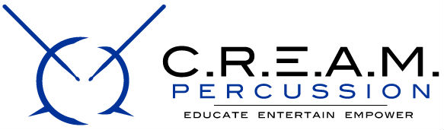

2018 Calendar of events (more dates pending)

DECEMBER

16nd Auditions
17th Auditions
23rd Auditions
24th Auditions
30th Final Auditions

JANUARY
6th & 7th Practice
13th & 14th Practice
15th MLK Day 5k Drum Run (Piedmont Park)
20th First Payment Due ($250)
20th & 21st Practice
27th & 28th Practice

FEBRUARY
3rd College Audition Prep Seminar
3rd & 4th Practice
10th & 11th Practice
11^{h} Uniform Fee Due ($120)
17th Second Payment Due ($300)
17th & 18th Practice
24th & 25th Practice
TBD College Audition Prep Seminar Mock Audition One

MARCH
3rd & 4th Practice
10th & 11th Practice
17th Third Payment Due ($300)
17th & 18th Practice
24th *Red Smooth Drumline Competition (North Carolina)
31st *Highland Springs Virginia Competition (North Carolina)
TBD College Audition Prep Seminar Mock Audition Two

APRIL

2nd Benedict College
2nd South Carolina State University
3rd Savannah State University
3rd Edward Waters College
4th Bethune Cookman
5th Florida A & M University
6th Alabama State University
6th Albany State University
21st *Battle in the Apple Drumline Competition (Highly Tentative)
28th *Edward Waters Drumline Competition (Tentative)
TBD Atlanta Invitational Battle of the Drumlines (presented by C.R.E.A.M) (Tentative)

MAY

7th *Warren County Drumline Competition
TBD *Madison Mission Drumline Competition (Tentative)
TBD SWD Drumline Exhibition
TBD Various Band Jamborees

JUNE

TBD City Wide Summer Percussion Camp (Tentative)
TBD End of Season Banquet

